Software Requirement Specification

Battleship Game

Table of Contents

1. Introduction

1.1 Purpose

1.2 Scope

1.3 Definitions, Acronyms, and Abbreviations

1.4 References

1.5 Overview

2. The Overall Description

2.1 Product Perspective

2.2 Product Functions

2.3 User Characteristics

2.4 Constraints

2.5 Assumptions and Dependencies

3. External interface Requirements

3.1 User Interfaces

3.2 Hardware Interfaces

3.3 Software Interfaces

3.4 Communications Interfaces

- System Features

- Other Non-Functional Requirements 5.1 Performance Requirements
5.1.1 Capacity
5.1.2 Dynamic Requirements
5.1.3 Quality

5.2 Software System Attributes

3.6.1 Reliability
3.6.2 Availability
3.6.3 Security
3.6.4 Maintainability
5.3 Business Rules

6. Other Requirements

Appendix A: Glossary

1. Introduction

Battleship is a war-themed strategy type game for two players in which the opponents try to guess the location of their opponent's warships and sink them. It is played on ruled grids on which each player's fleet of ships (including battleships) are marked. The locations of the fleets are concealed from the other player. Players alternate turns calling "shots" at the other player's ships. The objective of the game is to destroy the opposing player's fleet or to sink the opponent's entire fleet without them sinking the player's fleet first.

1.1 Purpose

This document describes the software requirements and specification for a battleship game that will be implemented by using C Programming language. The document is intended for the customer and the developer.

The reader is assumed to have basic knowledge of C Programming language. Knowledge and understanding of UML diagrams is also required.

1.2 Scope

This document applies to the Battleship game that we are working on during this semester. This software facilitates the user to be able to play the Battleship game on their own window (laptop or PC). This software offers the user to choose either to play it as a single player (vs. computer), which includes two difficulty levels or play it as a two-player game against another player. It also allows the player to choose the difficulty levels that they desire to play.
The software takes as input the name of the player login purposes. The outputs then comprise of an interactive display that lets the user select the desirable level of difficulty (if the user intends to play as a single player) or asking the second player’s name as an input (if the user intends to play it with another second user).

1.3 Definitions, Acronyms, and Abbreviations.

 | PC | Personal Computer
 | vs | Versus or against

1.4 References

The references for the above software are as follows:-

- www.google.com

- www.wikipedia.com

- IEEE. Software Requirements Specification Std. 830-1993.

1.5 Overview

Section 1.0 discusses the purpose and scope of the software. Section 2.0 describes the overall functionalities and constraints of
the software and user characteristics.
Section 3.0 details all the requirements needed to design the software.

2. The Overall Description

2.1 Product Perspective

The ATM is a single functional unit consisting of various sub-components.

This software allows the user to access their bank accounts remotely through an ATM without any aid of human bank teller.

This software also allows to perform various other functions apart from just accessing his bank account such as mobile bill clearings etc.

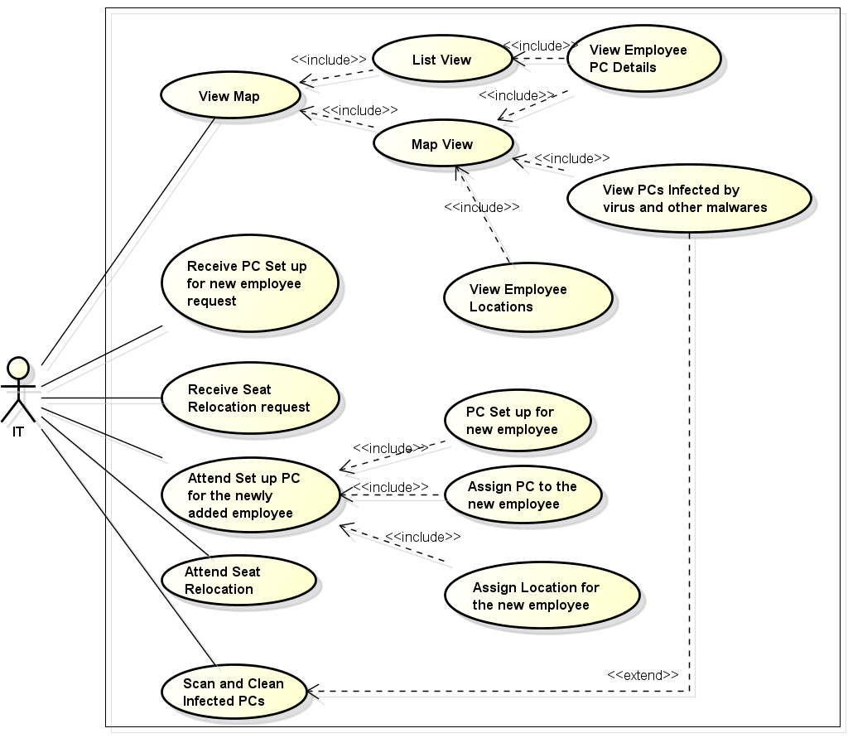

2.2 Product Functions

The major functions that ATM performs are described as follows:-

Language Selection:- After the user has logged in, the display provides him with a list of languages from which he can select any one in order to interact with the machine throughout that session. After the language selection the user is prompted with an option that whether he wants the selected language to be fixed for future use so that he is not offered with the language selection menu in future thus making the transaction a bit faster. User also has the freedom to switch to a different language mentioned in the list in between that session.

Account Maintenance:- The various functions that a user can perform
with his account are as follows:-

Account Type:-The user has the freedom to select his account type to which all the transactions are made, i.e. he can select whether the account is current account or savings account etc

Withdrawal/Deposit: The software allows the user to select the kind of operation to be performed i.e. whether he wants to withdraw or deposit the money.

Amount:- The amount to be withdrawn or deposited is then mentioned by the user.

Money Deposition:- Money deposition shall be done with an envelope. After typing the amount to be deposited and verification of the same, the customer must insert the envelope in the depositary.

Balance Transfer:- Balance transfer shall be facilitated between any two accounts linked to the card for example saving and checking account.

Balance Enquiry:- Balance enquiry for any account linked to the card shall be facilitated.

Billing:- Any transaction shall be recorded in the form of a receipt and the same would be dispensed to the customer. The billing procedures are handled by the billing module that enable user to choose whether he wants the printed statement of the transaction or just the updation in his account.

Cancelling:- The customer shall abort a transaction with the press of a Cancel key. For example on entering a wrong depositing amount. In addition the user can also cancel the entire session by pressing the abort key and can start a fresh session all over again.

Mobile Bills Clearings:- The machine also allows the user to clear off his pending mobile bills there only, if the name of his operator is mentioned there in the list. The machine displays the list of the companies supported by that bank to the user.

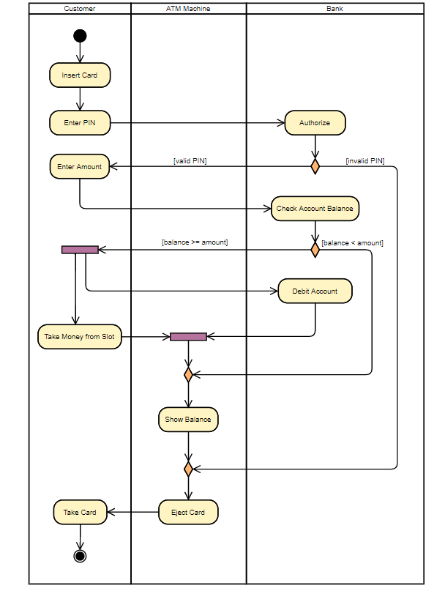

2.3 User Characteristics

There are different kinds of users that will be interacting with the system. The intended users of the software are as follows:-

There are several users of the ATM network:
1. Customers are simply members of the general public with no special training.
2. Bank security personnel need have no special education or experience.
3. Maintainers must be experienced network administrators, to be able to connect new ATMs to the network.

2.4 Constraints

The major constraints that the project has are as follows :-

The ATM must service at most one person at a time.

The number of invalid pin entries attempted must not exceed three. After three unsuccessful login attempts, the card is seized/blocked and need to be unlocked by the bank.

The simultaneous access to an account through both, the ATM and the bank is not supported.

The minimum amount of money a user can withdraw is (desired amount) and the maximum amount of money a user can withdraw in a session is (desired amount)

Before the transaction is carried out, a check is performed by the machine to ensure that a minimum amount is left in the user’s account after the withdrawal failing which the withdrawal is denied.

A user can select only that cellular operator for mobile bill clearings that is supported by the bank.

There shall be a printer installed with the machine to provide the user with the printed statement of the transaction.

